Introduction to the Beer Game

The purpose of the Beer Game is to experience systemic effects and to introduce the need for supply chain and network management. Specifically it shows:
- How single parts in a system influence each other.
- How individual thinking differs from systemic thinking (network thinking).
- Potentials for systems optimization and the use of information systems.

The Beer Game setup
The Beer Game supply chain consists of four stages:
- The retailer (red) has to fulfil the end consumer’s orders.
- The wholesaler (yellow) has to fulfil the retailer’s orders.
- The distributor (green) has to fulfil the wholesaler’s orders.
- The factory (blue) has to produce the beer to fulfil the distributor’s orders.

The Beer Game is played in groups of 3, each of these groups sits around one table and plays one supply chain stage (see figure).

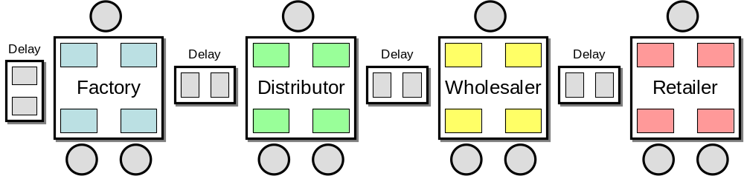

Every table has the same layout that shows four different areas (see figure):
- The place for incoming orders (inbox) – coming from the downstream stage
- The place for outgoing orders (outbox) – going to the upstream stage
- The place for incoming deliveries (receiving) – coming from the upstream stage
- The place for outgoing deliveries (dispatch) – going to the downstream stage

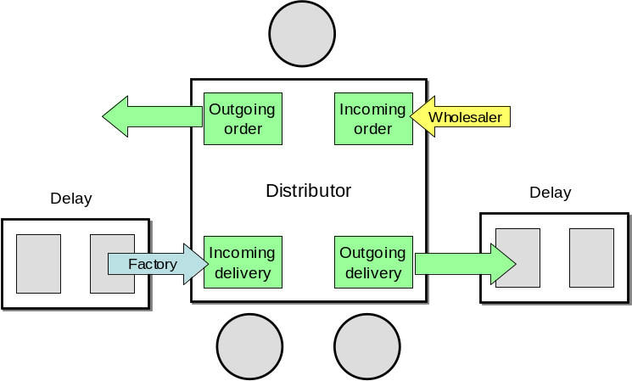
Deliveries are “on the road” for 2 weeks (lead time); production also takes 2 weeks. This lead time delay is represented by 2 two extra fields between the tables that hold the deliveries and are moved forward in each week.

General playing procedure
The game runs in weeks and it starts in week 1. In each week, each supply chain group has to proceed with the following steps:

- Receive new deliveries in the brown box and update the play sheet (“incoming delivery”).
- Receive orders in the envelop in your inbox and update the play sheet (“incoming order”)
- Prepare delivery: The playsheet calculates the amount that will be shipped (“your delivery”); note down this amount on a delivery slip and place it in the brown box in the dispatch area on your table.
- Place new order: Agree on a new order amount and update the playsheet. Note down the number on an order slip and place it in the envelope in your outbox field.

Your goal is to minimize your cost!

(Remember that you compete against the same stage in the other supply chain – retailer against retailer, distributor against distributor etc.)

There are two different kinds of cost:
- Inventory cost: Items in stock cost € 0,50 per week in holding costs.
- Backorder cost: If an incoming order cannot be (fully) fulfilled, items are outstanding and have to be put on “backorder” to be fulfilled in the following week(s). Each item on backorder costs € 1,00 per week.

What is a backorder?
If an incoming order cannot be fully fulfilled due to a lack of available items in the inventory, items go on backorder. In this case your inventory is empty and a number of items will appear as backorder in your play sheet.

What happens in the next week?
In the following week, the old backorder will be added to the new incoming order. Again, if the available inventory is too small to fulfil the outstanding order amount, items will be put on backorder.

Some general rules
- No communication is allowed between supply chain groups, supply chain groups must not talk to each other at any time!
  - Especially the customer demand is only known to the retailer.
- If stock is available, an order has to be fulfilled.
- Every order has to be fulfilled, either in the current week (if enough stock is available) or in one of the next weeks (items go on backorder).
- Either the inventory or the backorder, one of them is always zero (0)!

